Week- 6
1# Write a C program that uses functions to perform the following operations on a circular
Linked List
a. Creation
b. Insertion
c. Deletion
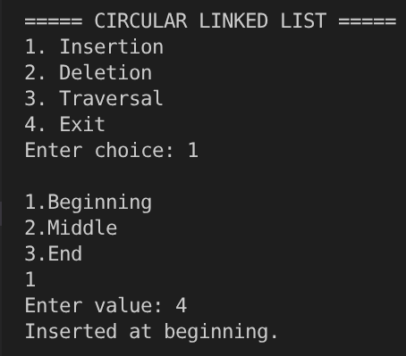
d. Traversal.

#include <stdio.h>
#include <stdlib.h>
struct node {
int data;
struct node *prev;
struct node *next;
};
struct node *head = NULL;
void insert_begin() {
struct node *newnode;
int value;
newnode = (struct node *)malloc(sizeof(struct node));
printf("Enter value: ");
scanf("%d", &value);
newnode->data = value;
if (head == NULL) {
head = newnode;
newnode->next = head;
newnode->prev = head;
}
} else {
newnode->next = head;
newnode->prev = head->prev;
head->prev->next = newnode;
head->prev = newnode;
head = newnode;
}
printf("Inserted at beginning.\n");
}
void insert_end() {
if (head == NULL) {
insert_begin();
return;
}
} else {
struct node *newnode, *temp;
int value;
newnode = (struct node *)malloc(sizeof(struct node));
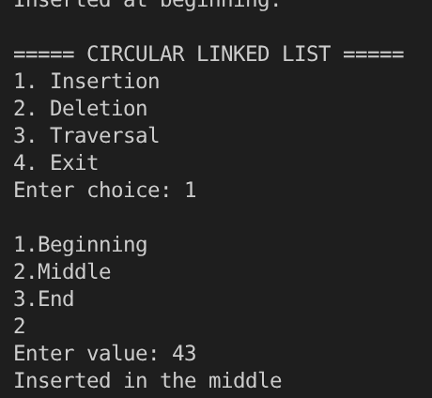
printf("Enter value: ");
scanf("%d", &value);
newnode->data = value;
temp = head;
while (temp->next != head) {
temp = temp->next;
}
newnode->next = temp->next;
temp->next->prev = newnode;
temp->next = newnode;
newnode->prev = temp;
}
printf("Inserted at end.\n");
}
void insert_middle() {
if (head == NULL) {
insert_begin();
return;
}
struct node *newnode, *temp;
int length = 1, i, value;
newnode = (struct node *)malloc(sizeof(struct node));
printf("Enter value: ");
scanf("%d", &value);
newnode->data = value;
temp = head;
while (temp->next != head) {
temp = temp->next;
length += 1;
}
temp = head;
for (i = 1; i < length / 2; i++) {
temp = temp->next;
}
newnode->next = temp->next;
newnode->prev = temp;
temp->next->prev = newnode;
temp->next = newnode;
printf("Inserted in the middle");
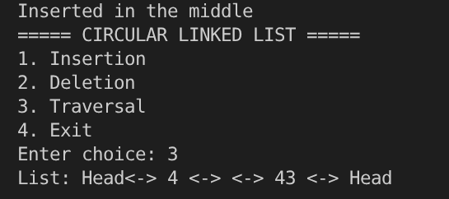
}
void delete_begin() {
struct node *temp;
if (head == NULL) {
printf("List empty.\n");
return;
}
temp = head;
if (head->next == head) {
head = NULL;
}
} else {
head->prev->next = head->next;
head->next->prev = head->prev;
head = head->next;
}
free(temp);
printf("First node deleted.\n");
}
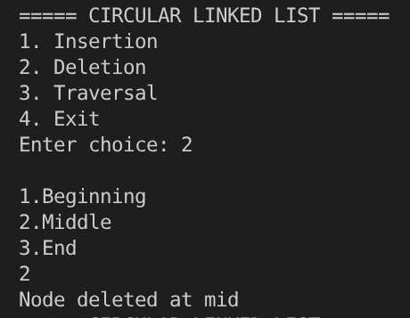
void delete_end() {
struct node *temp;
if (head == NULL) {
printf("List empty.\n");
return;
}
temp = head;
if (head->next == head) {
head = NULL;
}
} else {
temp = head->prev;
temp->prev->next = temp->next;
temp->next->prev = temp->prev;
}
free(temp);
printf("Last node deleted.\n");
}
void delete_middle() {
if (head == NULL) {
printf("List empty.\n");
return;
}
struct node *temp;
int length = 1, i;
temp = head;
if (head->next == head) {
head = NULL;
}
} else {
while (temp->next != head) {
temp = temp->next;
length += 1;
}
temp = head;
for (i = 0; i < (length + 1) / 2; i++) {
temp = temp->next;
}
temp->prev->next = temp->next;
temp->next->prev = temp->prev;
}
free(temp);
printf("Node deleted at mid");
}
void traversal() {
struct node *temp = head;
if (head == NULL) {
printf("List empty.\n");
return;
}
printf("List: ");
printf("Head<-> ");
while (temp->next != head) {
printf("%d <-> ", temp->data);
temp = temp->next;
}
printf("<-> %d <-> Head\n", temp->data);
}
int main() {
int choice, subchoice;
do {
printf("\n===== CIRCULAR LINKED LIST =====\n");
printf("1. Insertion\n");
printf("2. Deletion\n");
printf("3. Traversal\n");
printf("4. Exit\n");
printf("Enter choice: ");
scanf("%d", &choice);
switch (choice) {
case 1:
printf("\n1.Beginning\n2.Middle\n3.End\n");
scanf("%d", &subchoice);
if (subchoice == 1)
insert_begin();
else if (subchoice == 2)
insert_middle();
else if (subchoice == 3)
insert_end();
else
printf("Invalid option\n");
break;
case 2:
printf("\n1.Beginning\n2.Middle\n3.End\n");
scanf("%d", &subchoice);
if (subchoice == 1)
delete_begin();
else if (subchoice == 2)
delete_middle();
else if (subchoice == 3)
delete_end();
else
printf("Invalid option\n");
break;
case 3:
traversal();
break;
case 4:
printf("Program ended.\n");
break;
default:
printf("Invalid choice\n");
}
} while (choice != 4);
return 0;
}

Week- 7
Q1- Write a C program that implements a stack and its operations using
a. Arrays
#include <stdio.h>
#define N 25
struct stacktype {
int s[N];
int top;
};
typedef struct stacktype stack;
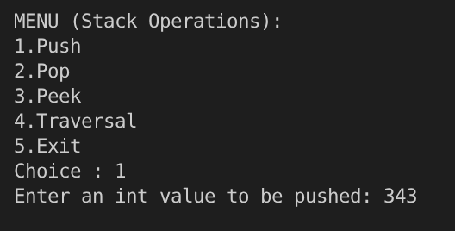
int isempty(int top) {
if (top == -1)
return 1;
return 0;
}
int isfull(int top) {
if (top == N - 1)
return 1;
return 0;
}
void push(stack *sp, int item) {
if (sp->top == N - 1) {
printf("Stack full/overflow -Insertion not possible\n");
return;
}
(sp->top)++;
sp->s[sp->top] = item;
}
int pop(stack *sp) {
int item;
if (sp->top == -1) {
printf("Stack empty/underflow -Deletion not possible\n");
return 0;
}
item = sp->s[sp->top];
(sp->top)--;
return item;
}
int peek(stack st) {
if (st.top == -1) {
printf("Stack empty\n");
return 0;
}
return st.s[st.top];
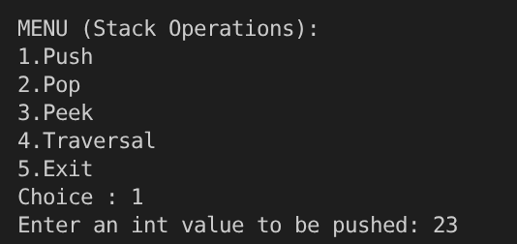
}
void traversal(stack st) {
int i = 0;
if (isempty(st.top)) {
printf("\nStack empty\n");
return;
}
printf("\nContents of Stack:\n");
while (i <= st.top)
printf("%d ", st.s[i++]);
printf("<-top\n");
}
main() {
int choice, item;
stack st;
st.top = -1;
do {
printf("\nMENU (Stack Operations):");
printf("\n1.Push\n2.Pop\n3.Peek\n4.Traversal\n5.Exit\n");
printf("Choice : ");
scanf("%d", &choice);
switch (choice) {
case 1:
printf("Enter an int value to be pushed: ");
scanf("%d", &item);
push(&st, item);
break;
case 2:
if (isempty(st.top))
printf("\nStack empty, deletion not possible\n");
else
{
item = pop(&st);
printf("Item popped= %d\n", item);
}
break;
case 3:
if (isempty(st.top))
printf("\nStack empty\n");
else
{
item = peek(st);
printf("Item at the top= %d\n", item);
}
break;
case 4:
traversal(st);
break;
}
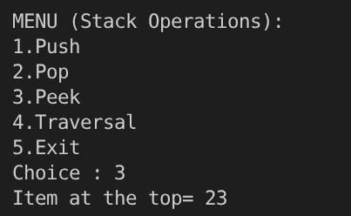
} while (choice != 5);
}
b. Linked List (Pointers).
#include <stdlib.h>
struct nodetype {
int INFO;
struct nodetype *NEXT;
};
typedef struct nodetype node;
int isempty(node *top) {
if (top == NULL)
return 1;
else
return 0;
}
node *push(node *top, int item) {
node *pnew = (node *)malloc(sizeof(node));
pnew->INFO = item;
pnew->NEXT = top;
printf("Node inserted...\n");
return pnew;
}
node *pop(node *top) {
node *pdel, *pnxt;
if (isempty(top))
{
printf("\nStack empty -Deletion not possible\n");
return top;
}
pdel = top;
pnxt = top->NEXT;
free(pdel);
printf("Node deleted...\n");
return pnxt;
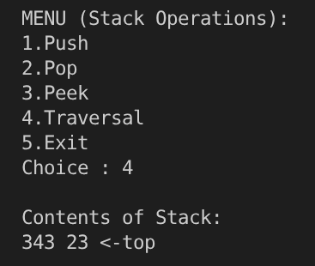
}
int peek(node *top) {
if (isempty(top))
{
printf("\nStack empty\n");
return 0;
}
return top->INFO;
}
void traversal(node *top) {
if (isempty(top))
printf("\nStack empty\n");
else
{
node *p = top;
printf("\nContents of Stack:\nTop-> ");
while (p != NULL)
{
printf("%d ", p->INFO);
p = p->NEXT;
}
printf("\n");
}
}
void main() {
int choice, item;
node *top = NULL;
do {
printf("\nMENU (Stack operations):");
printf("\n1.Push\n2.Pop\n3.Peek\n4.Traversal\n5.Exit\n");
printf("Choice : ");
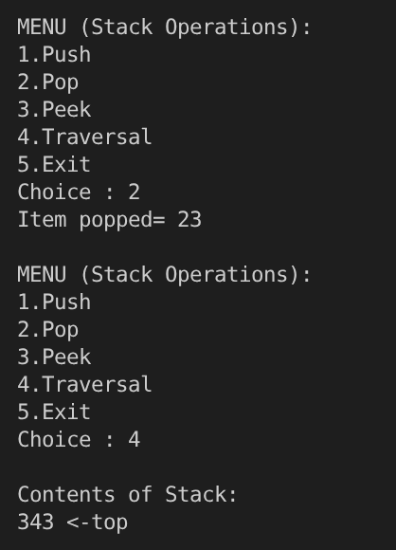
scanf("%d", &choice);
switch (choice) {
case 1:
printf("Enter int value to be pushed: ");
scanf("%d", &item);
top = push(top, item);
break;
case 2:
top = pop(top);
break;
case 3:
if (isempty(top))
printf("\nStack empty\n");
else
{
item = peek(top);
printf("\nItem peeked= %d\n", item);
}
break;
case 4:
traversal(top);
break;
}
} while (choice != 5);
}

Q2- Write a C program to convert the Infix expression into a Postfix expression.

#include <stdio.h>
#include <ctype.h>
#define MAX 100
char stack[MAX];
int top = -1;
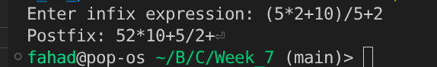
void push(char x) {
stack[++top] = x;
}
char pop() {
return stack[top--];
}
int precedence(char x) {
if (x == '+' || x == '-') return 1;
if (x == '*' || x == '/') return 2;
if (x == '^') return 3;
return 0;
}
int main() {
char infix[MAX], postfix[MAX];
int i = 0, j = 0;
printf("Enter infix expression: ");
scanf("%s", infix);
push('(');
strcat(infix, ")");
while (top != -1) {
char ch = infix[i++];
if (isalnum(ch)) {
postfix[j++] = ch;
}
else if (ch == '(') {
push(ch);
}
else if (ch == ')') {
while (stack[top] != '(')
postfix[j++] = pop();
pop(); // remove '('
}
else { // operator
while (precedence(stack[top]) >= precedence(ch))
postfix[j++] = pop();
push(ch);
}
}
postfix[j] = '\0';
printf("Postfix: %s", postfix);
return 0;
}

Q3- Write a C program to evaluate a postfix expression.
#include <stdio.h>
#include <ctype.h>
#include <math.h>
#define MAX 100
int stack[MAX];
int top = -1;
void push(int x) {
stack[++top] = x;
}
int pop() {
return stack[top--];
}
int evaluatePostfix(char P[]) {
int i = 0;
int a, b, result;
while (P[i] != '\0') {
if (isdigit(P[i])) {
push(P[i] - '0');
}
else {
a = pop();
b = pop();
switch (P[i]) {
case '+':
result = b + a;
break;
case '-':
result = b - a;
break;
case '*':
result = b * a;
break;
case '/':
result = b / a;
break;
case '^':
result = pow(b, a);
break;
}
push(result);
}
i++;
}
return pop();
}
int main() {
char P[MAX];
printf("Enter postfix expression: ");
scanf("%s", P);
int value = evaluatePostfix(P);
printf("Value = %d", value);
return 0;
}

Week- 8
Write a C program that implements Queue and its operations using
a. Arrays

#include <stdio.h>
#define MAX 1000
typedef struct {
int arr[MAX];
int front;
int rear;
} Queue;
int is_empty(Queue q) {
if ((q.front == -1 && q.rear == -1) || (q.front > q.rear))
return 1;
else
return 0;
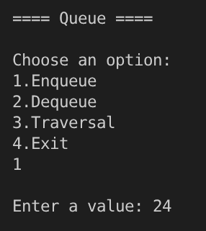
}
int is_full(Queue q) {
if (q.rear == MAX - 1)
return 1;
else
return 0;
}
void enqueue(Queue *q) {
if (is_full(*q)) {
printf("\nQueue full");
}
else if (is_empty(*q)) {
q->front = 0;
q->rear = 0;
printf("\nEnter a value: ");
scanf("%d", &(q->arr[q->rear]));
}
else {
q->rear += 1;
printf("\nEnter a value: ");
scanf("%d", &(q->arr[q->rear]));
}
}
void dequeue(Queue *q) {
if (is_empty(*q)) {
printf("Cannot remove (Queue already empty)");
}
else {
printf("Value dequeued is - %d", q->arr[q->front]);
q->front += 1;
}
}
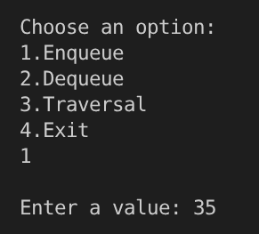
void traversal(Queue q) {
if (is_empty(q)) {
printf("Queue is empty");
}
else {
int i;
for (i = q.front; i <= q.rear; i++) {
printf("%d ", q.arr[i]);
}
}
}
int main() {
Queue q1;
q1.front = -1;
q1.rear = -1;
int choice;
printf("\n==== Queue ====\n");
do {
printf("\nChoose an option: ");
printf("\n1.Enqueue\n2.Dequeue\n3.Traversal\n4.Exit\n");
scanf("%d", &choice);
switch (choice) {
case 1:
enqueue(&q1);
break;
case 2:
dequeue(&q1);
break;
case 3:
traversal(q1);
break;
}
} while (choice != 4);
}
b. Linked List (Pointers).
#include <stdio.h>
#include <stdlib.h>

struct Node {
int data;
struct Node *next;
};
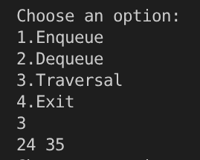
typedef struct Node Node;
struct Queue {
Node *front;
Node *rear;
};
typedef struct Queue Queue;
int is_queue_empty(Queue *queue) {
if ((queue->front == NULL)) {
return 1;
}
return 0;
}
Node *get_node() {
Node *n = (Node *)malloc(sizeof(Node));
n->next = NULL;
return n;
}
Queue *get_queue(void) {
Queue *q = (Queue *)malloc(sizeof(Queue));
q->front = NULL;
q->rear = NULL;
return q;
}
void enqueue(Queue *q, int data) {
Node *n = get_node();
Node *temp = q->front;
n->data = data;
if (is_queue_empty(q)) {
q->front = n;
}
else {
while (temp->next != NULL) {
temp = temp->next;
}
temp->next = n;
}
q->rear = n;
}
int dequeue(Queue *q) {
int del = q->front->data;
Node *temp = q->front;
if (q->front == q->rear) {
q->front = NULL;
q->rear = NULL;
}
else {
q->front = temp->next; // q->front-next
}
free(temp);
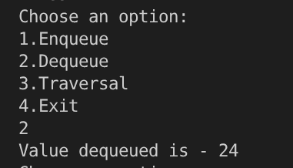
return del;
}
void traversal(Queue *q) {
if (is_queue_empty(q)) {
printf("Queue is empty");
}
else {
printf("[ ");
Node *temp = q->front;
while (temp->next != NULL) {
printf("%d ", temp->data);
temp = temp->next;
}
printf("%d ", temp->data);
printf("]");
}
}
int main() {
int choice, data;
Queue *q = get_queue();
printf("\n==== Queue ====\n");
do {
printf("\nChoose an option\n");
printf("1.Enqueue\n2.Dequeue\n3.Traversal\n4.Exit\n> ");
scanf("%d", &choice);
switch (choice) {
case 1:
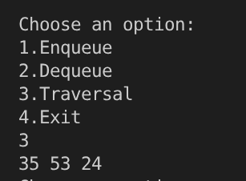
printf("Enter a value :");
scanf("%d", &data);
enqueue(q, data);
break;
case 2:
if (is_queue_empty(q))
{
printf("Queue is already empty");
}
else {
int deleted = dequeue(q);
printf("Node dequeued = %d", deleted);
}
break;
case 3:
traversal(q);
}
} while (choice != 4);
}

Week- 9
Q1- Write a C program that implements a Circular Queue using arrays.

#include <stdio.h>
#define MAX 10
struct circular_queue {
int arr[MAX];
int rear;
int front;
};
typedef struct circular_queue Queue;
int is_queue_empty(Queue *queue) {
if (-1 == queue->rear)
{
return 1;
}
return 0;
}
int is_queue_full(Queue *queue) {
{
return ((queue->rear + 1) % MAX == queue->front);
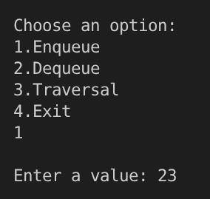
}
void enqueue(Queue *queue, int data) {
{
if (is_queue_empty(queue)) {
queue->front = 0;
queue->rear = 0;
}
else if (!(is_queue_full(queue))) {
queue->rear = (queue->rear + 1) % MAX;
}
queue->arr[queue->rear] = data;
}
int dequeue(Queue *queue) {
{
int data = queue->arr[queue->front];
if (is_queue_empty(queue)) {
}
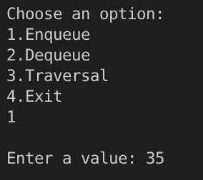
else if (queue->rear == queue->front) {
queue->front = -1;
queue->rear = -1;
}
else {
queue->front = (queue->front + 1) % MAX;
}
return data;
}
void traversal(Queue *queue) {
int index = queue->front;
while (index != queue->rear) {
printf("%d <- ", queue->arr[index]);
index = (index + 1) % MAX;
}
printf("%d ", queue->arr[index]);
}
Queue get_queue() {
Queue queue;
queue.front = -1;
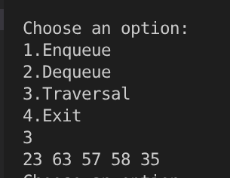
queue.rear = -1;
return queue;
}
int main() {
{
Queue queue1 = get_queue();
Queue *queue_pt = &queue1;
int choice, data;
printf("\n=== Queue ===");
do {
printf("\nChoose an option\n");
printf("1.Enqueue\n2.Dequeue\n3.Traversal\n4.Exit\n> ");
scanf("%d", &choice);
switch (choice) {
case 1:
if (is_queue_full(queue_pt))
{
printf("\nQueue is full");
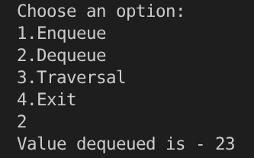
}
else
{
printf("Enter a value :");
scanf("%d", &data);
enqueue(queue_pt, data);
}
break;
case 2:
if (is_queue_empty(queue_pt))
{
printf("Queue is already empty");
}
else
{
int deleted = dequeue(queue_pt);
printf("Node dequeued = %d", deleted);
}
break;
case 3:
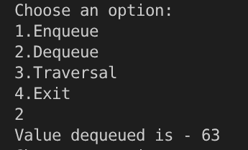
traversal(queue_pt);
break;
default:
printf("Invalid input");
}
} while (choice != 4);
}

Q2- Write a C program that uses both recursive and non-recursive functions to perform the
following searching operations for a key value in a given list of integers:
a) Linear search

#include <stdio.h>
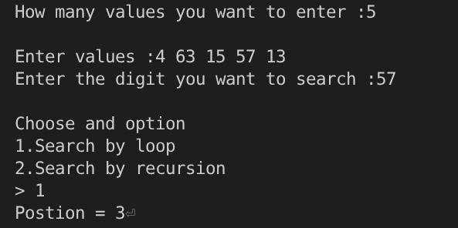
int linear_search_with_loop(int arr[], int size, int item) {
int i = 0;
while (i < size) {
if (arr[i] == item)
return i;
i++;
}
return -1;
}
int linear_search_with_recursion(int arr[], int size, int item, int i) {
if (i >= size) {
return -1;
}
if (arr[i] == item) {
return i;
}
return linear_search_with_recursion(arr, size, item, i + 1);
}
int main() {
int n, i, choice, postion, item;
printf("How many values you want to enter :");
scanf("%d", &n);
int arr[n];
printf("\nEnter values :");
for (i = 0; i < n; i++) {
scanf("%d", &arr[i]);
}
printf("Enter the digit you want to search :");
scanf("%d", &item);
printf("\nChoose and option\n");
printf("1.Search by loop\n2.Search by recursion\n> ");
scanf("%d", &choice);
if (choice == 1) {
postion = linear_search_with_loop(arr, n, item);
}
else if (choice == 2) {
postion = linear_search_with_recursion(arr, n, item, 0);
}
else {
printf("\nInvalid input");
}
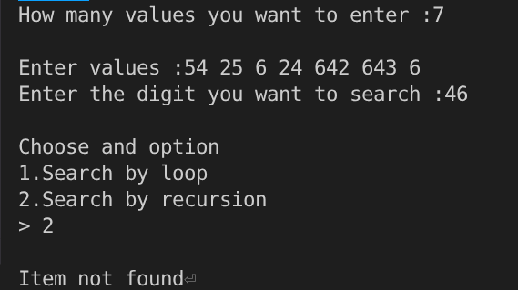
if (postion == -1) {
printf("\nItem not found");
}
else {
printf("Postion = %d", postion);
}
}
b) Binary search.
#include <stdio.h>
int binary_search_using_loop(int arr[], int size, int item) {
int mid;
int lb = 0;
int ub = size - 1;
while (lb <= ub) {
mid = (lb + ub) / 2;
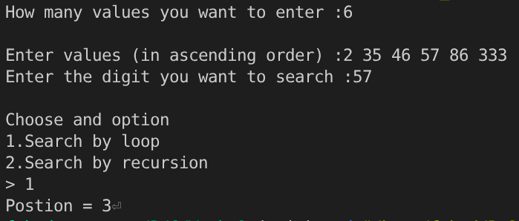
if (arr[mid] == item) {
return mid;
}
else if (arr[mid] > item) {
ub = mid - 1;
}
else {
lb = mid + 1;
}
}
}
int binary_search_using_recusrion(int arr[], int lb, int ub, int item) {
{
int mid = (lb + ub) / 2;
if (arr[mid] == item) {
return mid;
}
else if (arr[mid] > item) {
ub = mid - 1;
return binary_search_using_recusrion(arr, lb, ub, item);
}
else {
lb = mid + 1;
return binary_search_using_recusrion(arr, lb, ub, item);
}
}
int main() {
{
int n, i, choice, postion, item;
printf("How many values you want to enter :");
scanf("%d", &n);
int arr[n];
printf("\nEnter values :");
for (i = 0; i < n; i++) {
scanf("%d", &arr[i]);
}
printf("Enter the digit you want to search :");
scanf("%d", &item);
printf("\nChoose and option\n");
printf("1.Search by loop\n2.Search by recursion\n> ");
scanf("%d", &choice);
if (choice == 1) {
postion = binary_search_using_loop(arr, n, item);
}
else if (choice == 2) {
postion = binary_search_using_recusrion(arr, 0, n - 1, item);
}
else {
printf("\nInvalid input");
}
if (postion == -1) {
printf("\nItem not found");
}
else {
printf("Postion = %d", postion);
}
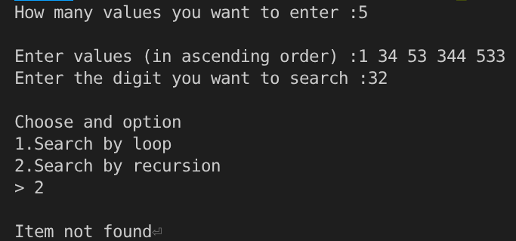
}

Week- 10
Write a C program that implements the following sorting algorithms.
a) Insertion sort for integers
b) Bubble sort for characters
c) Selection sort for integers
d) Quick sort for characters

#include <stdio.h>
void insertion_sort(int arr[], int size) {
int arr_ls, arr_fu, temp, pass;
for (pass = 1; pass < size; pass++) {
arr_fu = pass;
arr_ls = pass - 1;
temp = arr[arr_fu];
while (arr_ls >= 0 && arr[arr_fu] < arr[arr_ls]) {
arr[arr_ls + 1] = arr[arr_ls];
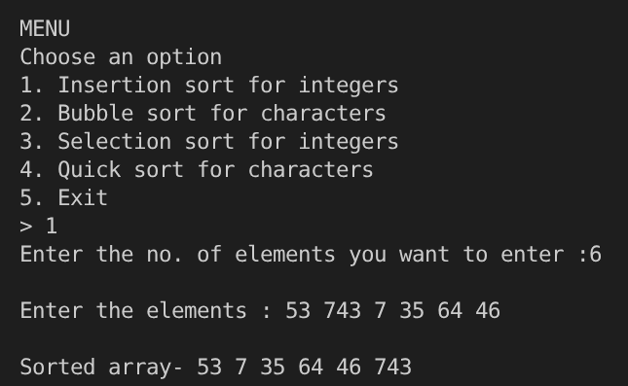
arr_ls--;
}
arr[arr_ls + 1] = temp;
}
}
void selection_sort(int arr[], int size) {
{
int temp, pass, i, local_min;
for (pass = 0; pass < size; pass++) {
local_min = pass;
for (i = pass; i < size; i++) {
if (arr[i] < arr[local_min]) {
local_min = i;
}
}
if (local_min != pass) {
temp = arr[pass];
arr[pass] = arr[local_min];
arr[local_min] = temp;
}
}
}
void int_traversal(int arr[], int size) {
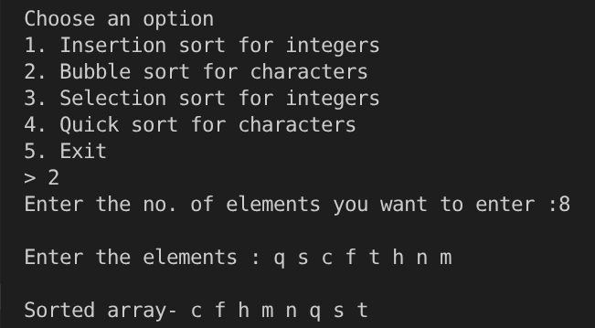
{
int i;
printf("\nSorted array- ");
for (i = 0; i < size; i++) {
printf("%d ", arr[i]);
}
}
void char_traversal(char arr[], int size) {
{
int i;
printf("\nSorted array- ");
for (i = 0; i < size; i++) {
printf("%c ", arr[i]);
}
}
void bubble_sort_for_char(char arr[], int size) {
{
int pass, i, temp, changed;
for (pass = 1; pass < size; pass++) {
changed = 0;
for (i = 0; i <= size - 1 - pass; i++) {
if (arr[i] > arr[i + 1]) {
temp = arr[i + 1];
arr[i + 1] = arr[i];
arr[i] = temp;
changed = 1;
}
}
if (!changed)
break;
}
}
void quicksort(char arr[], int lb, int ub) {
{
int j;
if (lb < ub) {
j = partition(arr, lb, ub);
quicksort(arr, lb, j - 1);
quicksort(arr, j + 1, ub);
}
}
int partition(char arr[], int lb, int ub) {
{
int i, j, key, temp;
i = lb + 1;
j = ub;
key = arr[lb];
while (i <= j) {
while (arr[i] < key && i <= j)
i++;
while (arr[j] > key)
j--;
if (i < j) {
temp = arr[i];
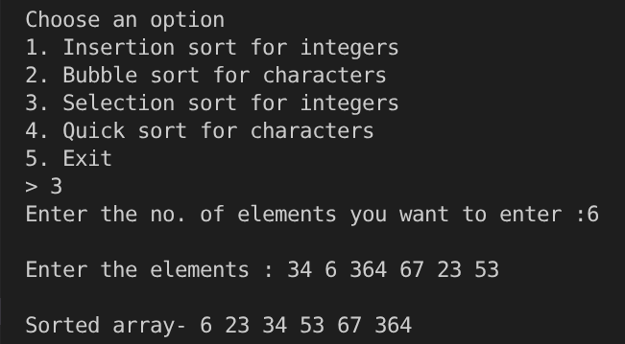
arr[i] = arr[j];
arr[j] = temp;
i++;
j--;
}
else {
}
temp = arr[lb];
arr[lb] = arr[j];
arr[j] = temp;
return j;
}
int main() {
{
int choice, size, i;
do {
printf("\nMENU\n");
printf("Choose an option\n");
printf("1. Insertion sort for integers\n2. Bubble sort for characters\n3. Selection sort for integers\n4. Quick sort for characters\n5. Exit\n> ");
scanf("%d", &choice);
switch (choice) {
{
case 1:
{
printf("Enter the no. of elements you want to enter :");
scanf("%d", &size);
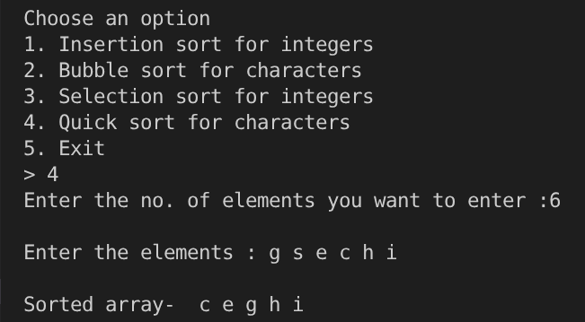
int arr[size];
printf("\nEnter the elements : ");
for (i = 0; i < size; i++) {
scanf("%d", &arr[i]);
}
insertion_sort(arr, size);
int_traversal(arr, size);
break;
}
case 2:
{
printf("Enter the no. of elements you want to enter :");
scanf("%d", &size);
char arr[size];
printf("\nEnter the elements : ");
for (i = 0; i < size; i++) {
scanf(" %c", &arr[i]);
}
bubble_sort_for_char(arr, size);
char_traversal(arr, size);
break;
}
case 3:
{
printf("Enter the no. of elements you want to enter :");
scanf("%d", &size);
int arr[size];
printf("\nEnter the elements : ");
for (i = 0; i < size; i++) {
scanf("%d", &arr[i]);
}
selection_sort(arr, size);
int_traversal(arr, size);
break;
}
case 4:
{
printf("Enter the no. of elements you want to enter :");
scanf("%d", &size);
char arr[size];
printf("\nEnter the elements : ");
for (i = 0; i < size; i++) {
scanf(" %c", &arr[i]);
}
quicksort(arr, 0, size);
char_traversal(arr, size);
break;
}
}
} while (choice != 5);
}

Week - 11
Write a C program that implements the following.
a) Counting sort
b) Merge sort
c) Heap sort

#include <stdio.h>
void printArray(int arr[], int n) {
printf("[ ");
for (int i = 0; i < n; i++)
printf("%d%s", arr[i], (i < n - 1) ? ", " : " ");
printf("]\n");
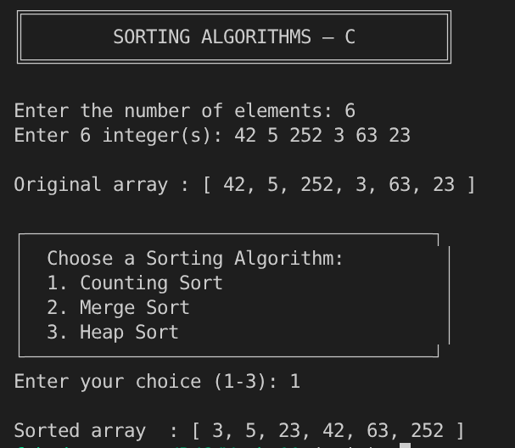
}
void countingSort(int arr[], int n) {
int max = arr[0], min = arr[0];
for (int i = 1; i < n; i++) {
if (arr[i] > max) max = arr[i];
if (arr[i] < min) min = arr[i];
}
int range = max - min + 1;
int count[range];
int output[n];
for (int i = 0; i < range; i++) count[i] = 0;
for (int i = 0; i < n; i++)
count[arr[i] - min]++;
for (int i = 1; i < range; i++)
count[i] += count[i - 1];
for (int i = n - 1; i >= 0; i--) {
output[count[arr[i] - min] - 1] = arr[i];
count[arr[i] - min]--;
}
for (int i = 0; i < n; i++)
arr[i] = output[i];
}
void merge(int arr[], int left, int mid, int right) {
int i = left;
int j = mid + 1;
while (i <= mid && j <= right) {
if (arr[i] <= arr[j]) {
i++;
} else {
int value = arr[j];
int k = j;
while (k > i) {
arr[k] = arr[k - 1];
k--;
}
arr[i] = value;
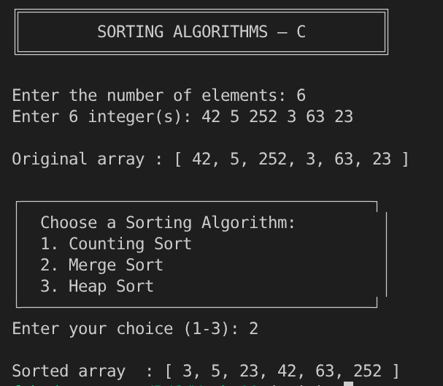
i++;
mid++;
j++;
}
}
}
void mergeSort(int arr[], int left, int right) {
if (left < right) {
int mid = left + (right - left) / 2;
mergeSort(arr, left, mid);
mergeSort(arr, mid + 1, right);
merge(arr, left, mid, right);
}
}
void heapify(int arr[], int n, int i) {
int largest = i;
int left = 2 * i + 1;
int right = 2 * i + 2;
if (left < n && arr[left] > arr[largest]) largest = left;
if (right < n && arr[right] > arr[largest]) largest = right;
if (largest != i) {
int temp = arr[i];
arr[i] = arr[largest];
arr[largest] = temp;
heapify(arr, n, largest);
}
}
void heapSort(int arr[], int n) {
for (int i = n / 2 - 1; i >= 0; i--)
heapify(arr, n, i);
for (int i = n - 1; i > 0; i--) {
int temp = arr[0];
arr[0] = arr[i];
arr[i] = temp;
heapify(arr, i, 0);
}
}
int main(void) {
printf("╔══════════════════════════════════════╗\n");
printf("║ SORTING ALGORITHMS — C ║\n");
printf("╚══════════════════════════════════════╝\n\n");
int n;
printf("Enter the number of elements: ");
if (scanf("%d", &n) != 1 || n <= 0) {
printf("Invalid input. Please enter a positive integer.\n");
return 1;
}
int arr[n];
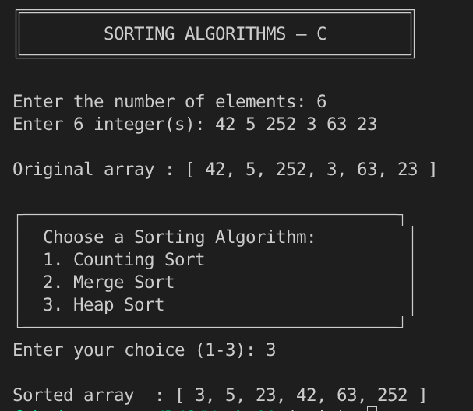
int workArr[n];
printf("Enter %d integer(s): ", n);
for (int i = 0; i < n; i++) {
if (scanf("%d", &arr[i]) != 1) {
printf("Invalid input!\n");
return 1;
}
}
printf("\nOriginal array : ");
printArray(arr, n);
int choice;
printf("│ Choose a Sorting Algorithm: \n");
printf("│ 1. Counting Sort \n");
printf("│ 2. Merge Sort \n");
printf("│ 3. Heap Sort \n");
printf("Enter your choice (1-3): ");
if (scanf("%d", &choice) != 1) {
printf("Invalid choice!\n");
return 1;
}
for (int i = 0; i < n; i++) workArr[i] = arr[i];
switch (choice) {
case 1:
countingSort(workArr, n);
break;
case 2:
mergeSort(workArr, 0, n - 1);
break;
case 3:
heapSort(workArr, n);
break;
default:
printf("Invalid choice! Please select 1, 2, or 3.\n");
return 1;
}
printf("\nSorted array : ");
printArray(workArr, n);
return 0;
}

Week- 12
Write a C program to perform the following operations:
a. Insert an element into a binary search tree.
b. Delete an element from a binary search tree.
c. Search for a key element in a binary search tree.

#include <stdio.h>
#include <stdlib.h>
struct Node {
int data;
struct Node *left;
struct Node *right;
};
struct Node *createNode(int value) {
struct Node *newNode = (struct Node *)malloc(sizeof(struct Node));
if (newNode == NULL) {
printf("Memory allocation failed!\n");
exit;
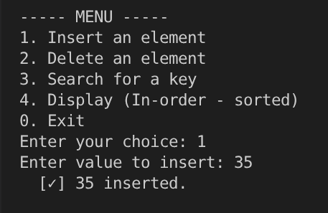
}
newNode->data = value;
newNode->left = NULL;
newNode->right = NULL;
return newNode;
}
struct Node *insert(struct Node *root, int value) {
if (root == NULL)
return createNode(value);
if (value < root->data)
root->left = insert(root->left, value);
else if (value > root->data)
root->right = insert(root->right, value);
else
printf(" [!] %d already exists in the BST. Duplicates not allowed.\n", value);
return root;
}
struct Node *findMin(struct Node *node) {
while (node->left != NULL)
node = node->left;
return node;
}
struct Node *deleteNode(struct Node *root, int value) {
if (root == NULL) {
printf(" [!] %d not found in the BST.\n", value);
return NULL;
}
if (value < root->data) {
root->left = deleteNode(root->left, value);
}
else if (value > root->data) {
root->right = deleteNode(root->right, value);
}
else {
if (root->left == NULL && root->right == NULL) {
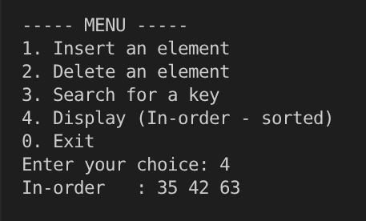
free(root);
return NULL;
}
if (root->left == NULL) {
struct Node *temp = root->right;
free(root);
return temp;
}
if (root->right == NULL) {
struct Node *temp = root->left;
free(root);
return temp;
}
struct Node *successor = findMin(root->right);
root->data = successor->data;
root->right = deleteNode(root->right, successor->data);
}
return root;
}
struct Node *search(struct Node *root, int key) {
if (root == NULL || root->data == key)
return root;
if (key < root->data)
return search(root->left, key);
else
return search(root->right, key);
}
void inorder(struct Node *root) {
if (root != NULL) {
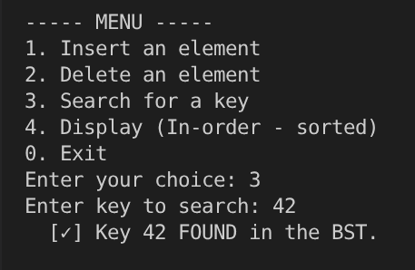
inorder(root->left);
printf("%d ", root->data);
inorder(root->right);
}
}
void freeTree(struct Node *root) {
if (root != NULL) {
freeTree(root->left);
freeTree(root->right);
free(root);
}
}
int main(void) {
struct Node *root = NULL;
int choice, value;
printf("========================================\n");
printf(" Binary Search Tree (BST) Operations \n");
printf("========================================\n");
do {
printf("\n----- MENU -----\n");
printf("1. Insert an element\n");
printf("2. Delete an element\n");
printf("3. Search for a key\n");
printf("4. Display (In-order - sorted)\n");
printf("0. Exit\n");
printf("Enter your choice: ");
scanf("%d", &choice);
switch (choice) {
case 1:
printf("Enter value to insert: ");
scanf("%d", &value);
root = insert(root, value);
printf(" [✓] %d inserted.\n", value);
break;
case 2:
if (root == NULL) {
printf(" [!] BST is empty.\n");
break;
}
printf("Enter value to delete: ");
scanf("%d", &value);
root = deleteNode(root, value);
printf(" [✓] Delete operation completed for %d.\n", value);
break;
case 3:
if (root == NULL) {
printf(" [!] BST is empty.\n");
break;
}
printf("Enter key to search: ");
scanf("%d", &value);
{
struct Node *result = search(root, value);
if (result != NULL)
printf(" [✓] Key %d FOUND in the BST.\n", value);
else
printf(" [✗] Key %d NOT FOUND in the BST.\n", value);
}
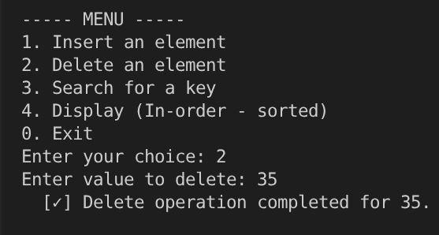
break;
case 4:
printf("In-order : ");
inorder(root);
printf("\n");
break;
case 0:
printf("Freeing memory and exiting...\n");
freeTree(root);
root = NULL;
break;
default:
printf(" [!] Invalid choice. Please try again.\n"); }
} while (choice != 0);
printf("Goodbye!\n");
return 0;}

